**NSSA-220 Mini Project 1: Application Performance Monitoring**

Siddhesh Periaswami, Kenneth Fan**,** Thomas Davis

**Introduction**

In this project, we wrote a script for the purpose of collecting and viewing the resources used by a pc over time. It uses multiple bash commands to collect multiple process and system level metrics and store them in an easily readable format. By providing this information to the user, it displays how capable the machine is to run the tasks it is presented during run time and how the resources are being used.

**Process Level Metrics**

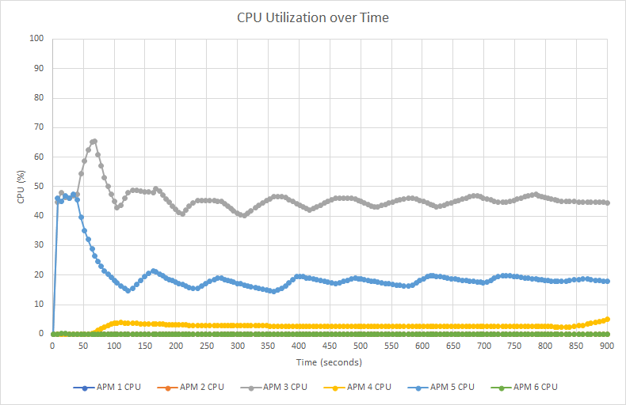

Describe what the CPU utilization plot shows in 2-3 sentences.

The CPU utilization plot shows the percentage of CPU used by the processes over the 15 minutes of run time. There is a seperate line for each of the 6 APMs which shows its specific percentage of CPU usage.

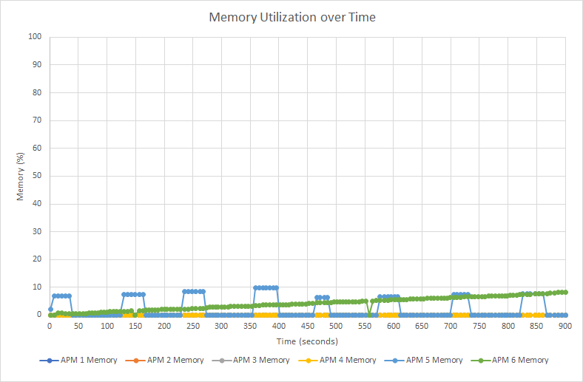

The memory utilization plot shows the percentage of memory used by the processes over the 15 minutes of run time. There is a seperate line for each of the 6 APMs which shows its specific percentage of memory usage.

**Potential things to write about**: Which processes used the most CPU/memory? Which processes used the least CPU/memory? Did any processes have any interesting patterns in their CPU and/or memory utilization? Could you see a memory leak (memory use that only increased over time) in any of the processes?

According to the graphs APM3 used the most CPU over time, remaining around 50% usage after its spike to 65% at about the one minute mark.

APM 6, 2 and 1 all had about the same CPU usage remaining at about 0% usage the entire time.

APM 5 had an interesting pattern in its memory and CPU usage. About every 120-140 seconds, the memory and CPU usage would spike up 5-10%.

Also we noticed there was a memory leak in APM 6 since it steadily increased its memory usage over time in a semi linear fashion.

**System Level Metrics**

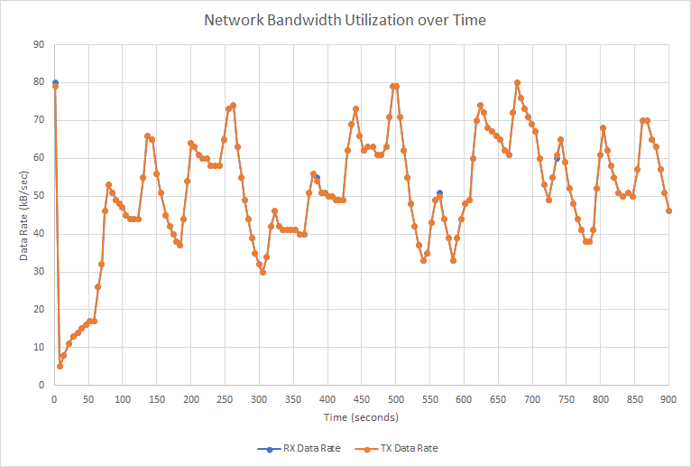

Describe what the network bandwidth utilization plot shows in 2-3 sentences.

The network bandwidth utilization plot shows the rate at which data was sent and received over the run time. Throughout the run time, our plot showed that the two rates remained at nearly the same levels as each other the entire time although the value changed often.

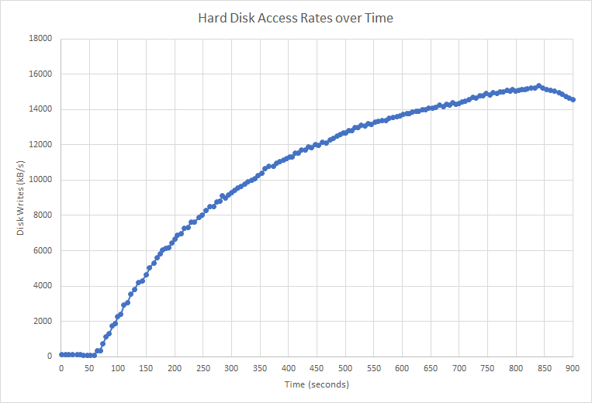

Describe what the hard disk access rates plot shows in 1-2 sentences.

The disk access rate plot displays the rate at which data was being written to the hard drive over the ruin time in kB/s. As displayed, it increased on a line with a decreasing slope over time until the final 50 seconds where it started to decrease.

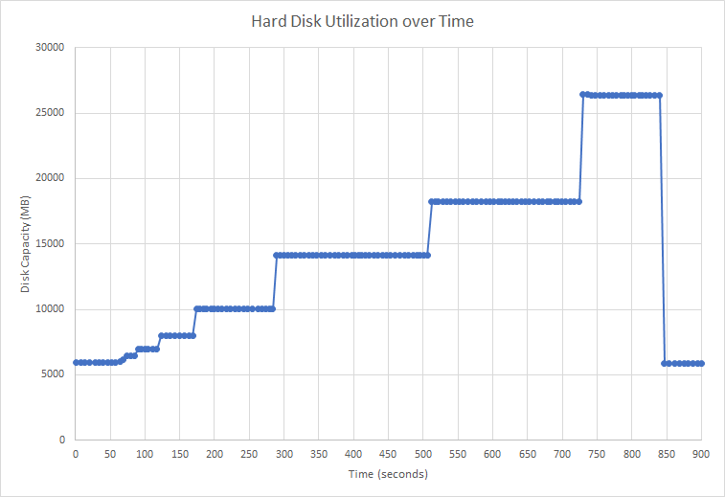

Describe what the hard disk utilization plot shows in 1-2 sentences.

The hard disk utilization plot shows the capacity of the hard disk that was used throughout the run time. As the space used increased, a similar trend was shown on the plot to represent the changes in capacity.

**Potential things to write about**: How similar (or not) were the transmit and receive data rates? Could you see any patterns in how the data rates changed over time? Were there any interesting patterns in the hard disk access rates or hard disk utilization?

The transmitting and receiving data rates were extremely similar down to only a few points that were different by a few kB/s. As the tx/rx rates increased, the capacity also increased and made increasingly large jumps up as time went on. The drop in tx/rx rates in the last 50 seconds also mirrors a large decrease in disk utilization at the same time into the run. The hard disk access rate increased over time until the last 50 seconds and the hard disk utilization also increased over time until the last 50 seconds.

**Summary and Lessons Learned**

Write 3-4 sentences that describe whether or not the VM you used had enough computing resources (CPU, memory, network capacity, and disk) to handle the mix of application processes that were running and what lessons you learned while working as a team on this project.

Although the CPU percentage neared 100% during the first minute, the rest of the time was fairly stable at around 60% usage. The memory was able to easily handle the tasks, although it most likely would have topped out if APM6 had run long enough for the memory leak to become a larger issue. The VM had trouble running the APMs, as it was difficult to use the VM after the script was running for a few minutes. The lessons that we learned as a team were to always test and review each other's code, as this helped create the script. One thing our team could work on would be testing the script earlier and communication.